Doctoral Occupational Therapy Capstone Report

Lulu (Lauren) Moretti
Department of Occupational Therapy, Xavier University
OCTD 802: Capstone Scholarship
Dr. Leah Dunn, EdD, OTR/L
November 2025

Table of Contents
Introduction to the Doctoral Capstone 5
Doctoral Capstone Title 5
Purpose of the Capstone Project 5
Theoretical Models 5
Content Area 5
Scholarship Type 5
Capstone Relationship to Mission and Philosophy 6
Xavier University Mission 6
Department of Occupational Therapy Mission 6
Department of Occupational Therapy Philosophy 6
Relationship 6
Capstone Development Part I 7
Capstone Site 7
Literature Review and Needs Assessment 7
Literature Review 7
Needs Assessment 7
Capstone Development Part II 8
Capstone Proposal 8
Capstone Goals and Objectives 8
Capstone Project Plan 8
Capstone Evaluation 8
Capstone Memorandum of Understanding 9
Capstone Implementation and Results 10
Activity 1 10
Description of the Participants 10
Implementation/Methodology 10
Results 10
Activity 2 10
Description of the Participants 10
Implementation/Methodology 10
Results 10
Activity 3 10
Description of the Participants 11
Implementation/Methodology 11
Results 11
Capstone Discussion 12
Evaluation of the Captone Project (Activity 1) and Correlation with Literature 12
Recommendations for Practice, Policy, and/or Education 12
Evaluation of the Captone Project (Activity 2) and Correlation with Literature 12
Recommendations for Practice, Policy, and/or Education 12
Evaluation of the Captone Project (Activity 3) and Correlation with Literature 12
Recommendations for Practice, Policy, and/or Education 12
Reflection of the Capstone 12
Reflective Synthesis/ Creative Epilogue 13
Appendix A: Literature Table 14
Appendix B: Scoping Review 15
Appendix C: IRB Application 16
Appendix E: Capstone Goals and Objectives for a Capstone Project Table and a Capstone Experience Table 17
Appendix F: Signed Memorandum of Understanding 18
Appendix G: IRB Letter of Response 19
Appendix H: Week-by-Week Project Plan 20

INSERT STATEMENT HERE

_____________________________________________ _____________________
Student Date
_____________________________________________ ___________________
Capstone Coordinator Date
_____________________________________________ ___________________
Faculty Mentor Date
_____________________________________________ ___________________
Capstone Site Mentor Date

Abstract
The Caregiver and Child Collaboration Toolkit: Cultivating Self-Regulation After ACEs focused on supporting children at GLAD House, a mental health treatment facility serving youth ages 5–12 impacted by parental substance abuse. These children experience high rates of adverse childhood experiences (ACEs), contributing to challenges in self-regulation, group participation, and healthy decision-making. This doctoral capstone aimed to enhance support through trauma-informed and collaborative approaches to enhance continuity of care. The project involved interviewing professionals to identify effective self-regulation strategies, developing visual and sensory supports for GLAD House, and connecting with local organizations to increase awareness of available community resources. These findings informed the creation of an educational module designed to strengthen communication among staff and providers, promoting consistent strategies and shared language to support children and caregivers. Project outcomes reflected three primary components. First, clinical observations informed comprehensive sensory support recommendations for group rooms, the sensory room, recess bin, and gross motor bin, which were compiled into a prioritization slideshow and Excel sheet used for future grant funding with one grant submitted during the capstone. Second, interviews exploring interprofessional perspectives on self-regulation and collaboration shaped the educational module, which incorporated ACEs education, evidence-based self-regulation frameworks, and community resources. Third, participation in resource tours and meetings resulted in a curated list of local services for caregivers and providers. Overall, the findings highlight the importance of accessible sensory tools, consistent language, and strengthened interprofessional collaboration to better support children who have experienced trauma.

Introduction to the Doctoral Capstone
The doctoral capstone is a culminating project and experience for doctoral capstone students that occurs after all clinical and didactic courses are completed. The evidence-based project requires the student to relate theory to practice, synthesizing in-depth knowledge in a specific practice area. The experience provides an in-depth exposure to a concentration area. Throughout the project and experience, the student is mentored by the capstone site (recipient), the Xavier University Faculty Mentor, and the Doctoral Capstone Coordinator.

This capstone proposal section contains the capstone title, purpose, theoretical models used, content area, type of scholarship, and the relationship to the Xavier University Mission and the Department of Occupational Therapy Mission and Philosophy.

Doctoral Capstone Title
Caregiver and Child Collaboration Toolkit: Cultivating Self-Regulation After ACEs

Purpose of the Capstone Project
The Caregiver and Child Collaboration Toolkit: Cultivating Self-Regulation After ACEs aimed to enhance support for children with adverse childhood experiences (ACEs) through trauma-informed, collaborative approaches. This project involved interviewing professionals to identify strategies for promoting self-regulation, developing visual and sensory supports for GLAD House, and connecting with local organizations to increase awareness of community resources. An educational module was then created to strengthen communication and collaboration among staff and providers, fostering consistent strategies and shared language to support self-regulation.

Theoretical Models
Below is a brief description of the conceptual or theoretical model(s) used to frame this capstone project and how it was applied.
This Doctoral Capstone was framed using two primary theoretical models: Ayres Sensory Integration and KAWA. Ayres Sensory Integration (ASI) is a theory that focuses on the brain’s ability to process and integrate sensory input, which is crucial for self-regulation, motor function, and behavior. To respond appropriately in social contexts, all eight senses must effectively interpret sensory information. However, many of the children at GLAD House are hypo- or hyper-responsive to sensory stimulation due to their traumatic experiences, which can often cause them to seek or avoid certain types of input. This variability highlights the need for safe, evidence-based sensory spaces within GLAD House. ASI will help guide the selection of appropriate, evidence-based sensory equipment that best supports the children’s needs.
The KAWA model is widely used to improve interprofessional collaboration, focusing on a community rather than an individual. It considers diverse environments and professional perspectives to foster harmony and collaborative problem-solving. Central to the KAWA model is identifying challenges and recognizing the unique contributions each profession can offer to support the children’s quality of life. For this Doctoral Capstone, the KAWA model will guide the development of focus groups and the creation of the educational module. It will ensure a holistic approach, emphasizing the importance of considering the larger context and integrating experiences of all team members while fostering effective language, communication, and strategies across disciplines.

Content Area
The goal of the doctoral capstone is to provide students with an in-depth exposure to one or more of the content areas. These include: clinical skills, research skills, program development and assessment, policy development, advocacy, education, and leadership. Students select a primary and secondary content area.
The primary content area of the project is education, as the development of an educational module was central to enhancing continuity of care and increasing professionals’ knowledge regarding self-regulation strategies, shared terminology, the impact of ACEs, and available community resources. GLAD House staff also received targeted instruction on the purpose and benefits of sensory supports, appropriate implementation methods, and evidence-informed self-regulation techniques. The secondary content area included advocacy, which was embedded throughout The Caregiver and Child Collaboration Toolkit: Cultivating Self-Regulation After ACEs. This included ongoing advocacy for expanding the role of occupational therapy (OT) within mental health settings, like GLAD House. Advocacy efforts also focused on the sensory needs of the children served. For example, after identifying that the end timer sound on the Time Timer was distressing for many children with trauma histories, I engaged in direct advocacy with the company. I met with the Co-President of Time Timer to bring attention to this concern and to collaborate on developing a more calming auditory option aligned with the sensory and emotional needs of the population.

Scholarship Type
Student capstone projects are considered scholarly studies. The project represents one of the four types of scholarship: (1) scholarship of discovery, (2) scholarship of application, (3) scholarship of teaching and learning.
Scholarship of application was integral to the development of The Caregiver and Child Collaboration Toolkit: Cultivating Self-Regulation After ACEs, as it centered on addressing practical, real-world challenges within the community setting. For instance, GLAD House had limited sensory supports, prompting a systematic exploration of both in-room and out-of-room sensory strategies and equipment to enhance therapeutic engagement. Based on these identified needs, a grant proposal was developed to secure funding for the recommended resources. Additionally, the project sought to resolve the broader issue of inconsistent language and approaches to self-regulation across professional disciplines. This was addressed by providing interdisciplinary education on evidence-based self-regulation strategies, promoting shared terminology, and disseminating community resources. These efforts aimed to strengthen interprofessional alignment and improve continuity of care for children and families.

Capstone Relationship to Mission and Philosophy
The doctoral capstone is related to the Xavier University Mission and the Department of Occupational Therapy Mission and Philosophy.

Xavier University Mission
Xavier is a Jesuit Catholic university rooted in the liberal arts tradition. Our mission is to educate each student intellectually, morally and spiritually. We create learning opportunities through rigorous academic and professional programs integrated with co-curricular engagement. In an inclusive environment of open and free inquiry, we prepare students for a world that is increasingly diverse, complex and interdependent. Driven by our commitment to educating the whole person, promoting the common good, and serving others, the Xavier community challenges and supports all our members as we cultivate lives of reflection, compassion and informed action.

Department of Occupational Therapy Mission
Our Mission is to educate and prepare future occupational therapists who respond to the occupational needs of a diverse, complex, interdependent, and ever-changing global society. Xavier University OTD graduates will practice as ethical, competent, and caring professionals using critical, creative, and reflective thinking and habits of lifelong learning. As professionals, Xavier University graduates will balance autonomous and collaborative decision-making to successfully navigate a variety of inclusive delivery systems in traditional and emerging practice areas where they implement theory-driven and evidence-based practice. Xavier University graduates will be leaders who model and advocate for justice for persons, groups, and populations. To promote occupational participation and advance the profession, our graduates will utilize, produce, and disseminate scholarly works.

Department of Occupational Therapy Philosophy
We believe:
- Humans are biopsychosocial beings who are transformed by participation in occupation.
- Participation in meaningful occupations shapes human lives and is intrinsically connected to one’s health and well-being.
- As members of intra- and inter-professional teams, occupational therapists form a dynamic and collaborative relationship with people, populations, and communities to maximize occupational participation and realize occupational potential.
- Best practice in occupational therapy is client-centered, occupation-based, theory-driven, evidence-based, and grounded in sound ethical principles.
- Students learn best through independent exploration coupled with active engagement in authentic and learner-centered learning experiences and self-reflection.

Relationship
Below is a description of the relationship between the doctoral capstone and the mission of the Xavier University and the mission and philosophy of the Department of Occupational Therapy meeting ACOTE standard D.1.3).
The Caregiver and Child Collaboration Toolkit: Cultivating Self-Regulation After ACEs aligns closely with Xavier University’s (XU) mission and the OTD Program’s mission and philosophy because of the emphasis on collaboration and interprofessional engagement. XU’s mission centers on fostering students who are equipped to work within diverse teams and collaborate in solidarity to promote the common good. Similarly, the OTD Program focuses on prepares students to work collaboratively in evidence-based, interprofessional settings, and advocate for people and communities. Specifically, this Doctoral Capstone emphasizes the importance of interprofessional collaboration between educators, social workers, psychologists, occupational therapists (OT), and more. My goal is to stand in solidarity with these professionals, gaining a deeper understanding of their experiences and perspectives. Through this collaboration, I will develop and provide an evidence-based educational module to empower professionals to better advocate for the children they serve, enhancing their occupational participation and helping them achieve their full potential.

Capstone Development Part I

Part I of the capstone development includes a literature review, site interview, and needs assessment. These form the foundation of the capstone project described in the following section of this proposal. This section provides documented evidence of ACOTE standard D.1.3 which states that “the doctoral capstone is an integral part of the program’s curriculum design’ and reflects the mission and philosophy of the program, contributes to the development of in-depth knowledge in a designated area of interest, and includes preparation consisting of a literature review and needs assessment” (ACOTE, 2023)

Capstone Site
The capstone site is the organization in which the student partners to complete the project and experience. The site is selected in collaboration with the student, doctoral capstone coordinator, and the faculty mentor.
GLAD House, which stands for Giving Life a Dream, is a mental health treatment center that serves children ages 5 to 12 in Hamilton County who have experienced caregiver substance abuse. The nonprofit provides an after-school program during the school year from Monday to Thursday, 3:00 p.m. to 6:00 p.m. and during the summer, programming is offered from Monday to Friday, 10:00 a.m. to 3:00 p.m. Children are placed into three groups based on age and developmental level. The youngest group typically includes children ages 5 to 8. The middle group usually includes children ages 8 to 10, and the oldest group includes children ages 10 to 12. GLAD House also offers therapy services and case management for children and their families. Much of the mental health support the children receive occurs in group sessions that focus on social and emotional skills, addiction and substance use prevention, and culturally informed activities. Although GLAD House is centered on mental health treatment, it also provides a safe and nurturing environment where children can simply be children. They are encouraged to play, explore their surroundings, and build healthy social connections.
The children at GLAD House have all experienced at least one adverse childhood experience (ACE) due to parental substance use, with an average of seven ACEs per child (K.N., personal communication, Oct. 28, 2025). Such high levels of adversity place them at elevated risk for chronic stress and impairments in executive functioning. Repeated exposure to threat during early development alters brain regions responsible for emotional regulation, impulse control, and coping (CDC, 2025). This leads to a sensitized nervous system that more readily shifts into trauma responses. These neurobiological changes significantly hinder self-regulation. Children with high ACE scores often struggle to interpret internal states, manage emotional intensity, recover from stress, and maintain behavioral control in group settings (Cleveland Clinic, 2025). Because self-regulation supports healthy decision-making and adaptive behavior, strengthening these skills is critical for mitigating long-term negative outcomes.

Literature Review and Needs Assessment

Literature Review
The doctoral capstone literature review was conducted in OCTD 604 (See Appendix A: Literature Table), OCTD 633, and OCTD 705 (See Appendix E: IRB Letter of Response).

Needs Assessment
Needs Assessment for the doctoral capstone was completed in OCTD 604 in collaboration with the student, faculty mentor, and doctoral capstone coordinator and was used as the foundation for this doctoral capstone. The Needs Assessment contains parts: (1) review of the literature, (2) description of the problem, and (3) site interview. See Appendix B: Needs Assessment.

Capstone Development Part II

The section contains the doctoral capstone proposal, which includes the goals and objectives, week-by-week project plan, and capstone evaluation plan. This section contains evidence that the doctoral capstone was “designed through collaboration with the student, a faculty member in the occupational therapy educational program who holds a doctoral degree, and an individual with documented expertise in the content area of the capstone” (ACOTE D.1.1, 2023), contains “goals/objectives, and a plan to evaluate project outcomes” (ACOTE, D.1.3), and that the site mentor (content expert) was “informed of the plan for and purpose of the doctoral capstone” (ACOTE D.1.2).

Capstone Proposal

Capstone Goals and Objectives
Goals and objectives are defined for both the capstone (1) project and (2) experience. The goals describe what students will learn or do, while the objectives define how this will be accomplished. Each goal and objective is listed with the proposed evidence of achievement for each. There is one table for the capstone project goals and objectives, and a separate table for the capstone experience. See Appendix C: Capstone Goals and Objectives for a Capstone Project Table and a Capstone Experience Table.

The doctoral capstone experience learning goals and objectives, as well as the project goals and objectives, were collaboratively developed by the student, faculty mentor, and doctoral capstone coordinator. All goals and objectives were reviewed with the site mentor. Evidence of this is provided in the site mentor-signed Memorandum of Understanding which contains the individual student goals and objectives. See Appendix D: Signed Memorandum of Understanding.

Capstone Project Plan
The capstone project plan consists of a Week-by-Week Project Plan and the procedures section of the IRB Application. Each was collaboratively developed by the student, faculty mentor, and doctoral capstone coordinator. See Appendix E: IRB Letter for the Response to the IRB Application. See Appendix H: Week-by-Week Table for the planned capstone activities by week.

Capstone Evaluation
The capstone evaluation is determined by assessing the student’s ability to meet their capstone goals and objectives. The capstone evaluation is divided into two sections: (1) project and (2) experience and is completed at mid-term (approximately week 7) and again at week 14 (final). The mid-term and final capstone evaluations are completed and maintained on EXXAT/Prism.

Capstone Memorandum of Understanding
A capstone Memorandum of Understanding (MOU) is executed prior to the start of the doctoral capstone and contains the roles and responsibilities of all parties, plans for evaluation, mentoring and supervision (ACOTE, 2023, D.1.4). See Appendix D: Signed Memorandum of Understanding.

Capstone Implementation and Results

This section contains a description of the implementation of the capstone project, results, summary, and reflection. This section is completed during OCTD 802: Capstone Scholarship.

Activity 1

Enhancing Sensory Supports for Self-Regulation – After observing each group and the children’s interactions, sensory support recommendations were developed for the group rooms, recess bin, gross motor bin, and sensory room. The accompanying slideshow outlines each recommended item with images, quantities, and prices, while the Excel sheet includes item names, prices, and purchase links. Each sensory supply was prioritized in a hierarchy based on available space, potential impact on the children served, and existing resources. Three levels of need were established, with level three representing the lowest priority. Additionally, a “dream sensory supply list” was created to illustrate an ideal setup without constraints of space or budget.

Description of the Participants
GLAD House serves children who have experienced parental or caregiver substance abuse. On average, each child has endured seven adverse childhood experiences (ACEs), and all have been exposed to non-accidental trauma (K.N., personal communication, Oct. 28, 2025). The program consists of three groups primarily organized by age, with developmental level also considered. The youngest group includes children ages 5–8, the middle group ages 8–10, and the oldest group ages 10–12. All participants reside in Hamilton County and can function in a group setting.

Implementation/Methodology
Clinical observations of all children at GLAD House informed recommendations for needed sensory supplies and identified existing resources. Over the course of a month in each group, I observed sensory needs, current supports, and the language used around them. I also accompanied clients during breaks to assess their use of the gross motor bin and sensory rooms and made additional observations during recess. Sensory supports were trialed in group rooms under the OT student’s guidance and implemented by group leaders. Although I initially planned to assist with grant writing, extended observation time was necessary to ensure recommendations were broadly applicable. The finalized slideshow and Excel sheet of sensory recommendations were presented to the executive and clinical directors to support future grant applications. The Development Director and I worked together to submit an application to the Max and Victoria Dreyfus Foundation for funding for the sensory equipment I recommended.

Modifications
Initially, I planned to provide sensory support recommendations only for the gross motor bin and sensory room. However, after recognizing that a primary goal was to keep clients engaged within their group rooms, I expanded the recommendations to include in-room sensory supports. The sensory room, recess bin, and gross motor bin also required upgrades due to limited options to enhance self-regulation sensory system activation. Observation and grant-writing timelines were adjusted once it became clear that attendance varied, with some children attending only once or twice a week, limiting consistent observation. One grant submission was completed with support from the Development Director to the Max and Victoria Dreyfus Foundation for sensory supplies. After further discussions, GLAD House administration decided to pursue additional grants independently following my departure. Additionally, trialing new sensory supplies required time, as each new item initially drew high interest from all clients. Sensory items were trialed with Xavier supplies, then durable equipment was recommended. Another modification required was the use of the auditory aspect of Time Timers. Majority of the children had adverse reactions to the loud end sound the timers would make but benefitted greatly to the visual timer. After meeting with the co-president of Time Timer, he put me in contact with their product designer and then offered to donate timers.

Results
The project outcomes included a sensory recommendation prioritization slideshow and an accompanying Excel sheet including all sensory equipment recommended (see Appendix G: Sensory Support Recommendations). These resources outline suggested items for in-room sensory supports, as well as for the sensory room, gross motor bin, and recess bin. Each item and its prioritization were reviewed with the clinical and executive directors to explain their benefits and intended use. GLAD House plans to pursue grant funding to obtain the recommended supplies with one grant through the Max and Victoria Dreyfus Foundation being applied for throughout my capstone process. Additionally, the co-president of Time Timer offered to donate timers to support self-regulation, and visual materials were created to enhance visual supports within each group room. The project also emphasized standardizing the language used around coping skills to ensure consistency and promote a shared understanding of the children’s self-regulation strategies. Upon arrival of the new materials, Dr. Leah Dunn has offered to provide staff training on the effective and appropriate use of the sensory supports.

Activity 2
Use Your Voice! – This component of the project required Institutional Review Board (IRB) approval, which took longer than anticipated. Once approval was obtained, emails were distributed to GLAD House and Xavier University contacts to reach a broad range of professionals working with children who have experienced non-accidental trauma. Interviews explored barriers to interprofessional communication, self-regulation strategies, professionals’ roles in supporting children, and the language used around self-regulation. Following the interviews, an educational module was developed that included information on self-regulation strategies, adverse childhood experiences (ACEs), and community resources. A post-module survey was incorporated to evaluate participant feedback and identify areas for improvement.

Description of the Participants
Participants included professionals working with children who have experienced non-accidental trauma within the greater Cincinnati area. The initial invitation email was distributed to social workers, psychologists, foster parents, Job & Family Services (JFS) workers, Court-Appointed Special Advocates (CASA) volunteers, Guardians ad Litem, case managers, therapists, educators, and others. Ultimately, social workers, psychologists, educators, occupational therapists (OTs), and a child life specialist participated in the interviews. Of the ten interviews conducted, five were with GLAD House staff representing diverse educational and professional backgrounds.

Implementation/Methodology

To recruit participants, GLAD House provided a list of contacts who frequently worked with the children or served as referral sources, along with additional contacts recommended by staff. Xavier University’s OT Department also contributed by sharing potential participants’ email information. Approximately 80 individuals received the initial recruitment email and were encouraged to share it with their peers. Due to limited initial responses, a modification request was submitted to the IRB, which is described in detail below. Following approval, 12 individuals agreed to participate, with 10 completing interviews and two who were unable to reschedule. The study utilized a qualitative interview methodology to explore professional perspectives on self-regulation and interprofessional collaboration among those working with children who have experienced non-accidental trauma. Open coding was applied to interview transcripts to identify themes across disciplines. Based on these findings, an educational module was developed that incorporated self-regulation strategies, information about adverse childhood experiences (ACEs), descriptions of professional roles, and community resources. A post-module survey was then distributed to assess participant learning outcomes and identify opportunities for improvement.

Modifications
Recruiting participants without offering incentives and obtaining IRB approval required multiple modification submissions. The IRB process took longer than anticipated, limiting the time available for provider interviews. Additional modification requests were submitted to approve the follow-up reminder email, as well as the educational module and post-module survey. Recruitment also expanded to contacts through Xavier University.

Results
The outcomes of the project included the development of an educational module, which consisted of a recorded audiovisual presentation designed for study participants (see Appendix F: Educational Module). Analysis of survey results remains incomplete due to delays associated with IRB approval. Data obtained from the interviews provided a foundation for the module, informing content that aimed to enhance professionals’ understanding of self-regulation and the terminology employed when discussing these strategies with children and their caregivers. The topics included within the educational module were the impacts of ACEs, Dan Siegel’s Hand Brain model, sensory systems, The Alert Program, The Interoception Curriculum, The Zones of Regulation, and the importance of co-regulation. Community resources also were added to the educational module with links and information about each resource. Furthermore, GLAD House staff participated in a training informed by the findings but adapted to be more geared toward implementation, with the goal of standardizing language and interventions related to self-regulation. This training introduced evidence-based frameworks and concepts related to self-regulation, including The Alert Program, interoception, Zones of Regulation, and emphasized the role of co-regulation in supporting child development.

Activity 3
Community Resource Exploration – An integral component of the overall project involved conducting tours and meetings with local community resources. The goal was to develop a concise list of local services that providers could share with caregivers, emphasizing the critical role these resources play in supporting children who have experienced trauma. Engaging directly with staff allowed for a deeper understanding of each organization’s scope, services, and expectations for their target populations, ensuring that recommendations were both accurate and practically relevant to the families and professionals served.

Description of the Participants
The participants were the staff at the local organizations, as well as the caregivers who will hopefully receive the information from these resources.

Implementation/Methodology
The project plan included my participation in GLAD House’s collaborative efforts with local organizations, particularly those involved in the Helpful Empowered Youth (HEY!) initiative. To strengthen connections with referral sources, I accompanied the case manager and clinical director to meetings and tours of local resources, gaining firsthand insight into the services and supports available. Additionally, I attended a local resource fair for high school students interested in careers in mental health, further expanding my understanding of community engagement and workforce development in the field.

Results

Within the educational module, a dedicated slide was included for each local resource, detailing the age ranges served and the specific services offered. This process also enhanced my awareness of community resources that may be utilized in future practice. Additionally, the GLAD House case manager has access to this comprehensive resource information, enabling her to share it effectively with caregivers and other referral sources.

Capstone Discussion

The discussion section contains an interpretation of the results and explains their significance. This can include a connection to the broader context, evaluation of the significance, acknowledgement of limitations, and proposed future direction of research or unanswered questions.

Evaluation of the Captone Project (Enhancing Sensory Access for Self-Regulation) and Correlation with Literature -
Through completing sensory support recommendations and reviewing durable equipment, I developed a deeper appreciation for the principle that regulation must precede expectation, a concept emphasized in trauma-informed and sensory integration literature. Clinical observations at GLAD House reinforced that non-accidental trauma and adverse childhood experiences (ACEs) often contribute to sensory processing challenges. Research shows that early trauma can alter neural connections during critical periods of development, disrupting typical sensory and motor maturation (Matson et al., 2023). Providing access to appropriate sensory tools supports individualized calming and alerting input, which literature identifies as essential for developing physiological regulation and higher-level skills. Sensory exploration further strengthens brain–body connections and promotes language, motor development, cognition, self-regulation, and social interaction (Cleveland Clinic, 2022). For children with significant trauma histories, establishing a sense of safety is foundational before any further instructions. Thus, structured sensory exploration within GLAD House’s supportive environment, paired with the recommended equipment, aligns with current evidence as an effective way to strengthen developmental outcomes and improve self-regulation.
Recommendations for Practice, Policy, and/or Education
Within OT education, it would be beneficial to incorporate more comprehensive instruction on identifying indicators of underdeveloped or dysregulated sensory systems. Although I engaged extensively in clinical observations during my time at GLAD House, I did not always feel confident in selecting or recommending appropriate sensory tools. Much of my learning occurred through trialing various sensory supports with multiple children, which highlighted the need for clearer guidance on the clinical observation skills required to accurately assess sensory processing differences. Additionally, my introduction to the “cup analogy,” which was integrated into my educational module, provided a helpful framework for conceptualizing and communicating over- and under-responsive sensory patterns. Furthermore, deeper educational emphasis on interoception, including strategies to assess and improve interoceptive awareness, is essential. Interoception plays a critical role in self-regulation, body awareness, emotional processing, and overall occupational performance. Strengthening this content area would better prepare students to support clients with complex sensory and regulatory needs. Lastly, while trauma-informed care is referenced frequently throughout Xavier’s curriculum, I often felt uncertain about how to translate these principles in practice. Offering more applied learning experiences, accompanied by constructive feedback, would likely strengthen students’ competence and confidence in implementing trauma-informed approaches within clinical settings.

Evaluation of the Captone Project (Use Your Voice!) and Correlation with Literature

After completing the interviews, I gained a deeper appreciation for the distinct value that OT contributes to discussions of self-regulation. Although nearly all participating professionals reported familiarity with or use of the Zones of Regulation, only OT practitioners had knowledge of The Interoception Curriculum or the Alert Program (Kuypers, L., 2011; Mahler, K., 2017; Williams, M.S. & Shellenberger, S., 1996). These findings highlight a significant gap in education surrounding self-regulation frameworks, curricula, and evidence-based programs among providers who regularly work with pediatric populations. The interviews reaffirmed the principle of “regulation before expectation,” emphasizing that children must first feel safe and regulated before they can reasonably be expected to attend, follow directions, or engage in appropriate behavior. Furthermore, I observed that many professionals rely on strategies that do not fully consider the sensory systems of self-regulation. In contrast, OTs are uniquely positioned to address sensory processing challenges, particularly among children who have experienced ACEs, by facilitating safe sensory exploration and offering individualized sensory-based supports. Finally, the interviews revealed notable variation in terminology across disciplines, including differing labels for tools such as fidgets. As a result, establishing consistent and clear language emerged as an essential component of the project.

Recommendations for Practice, Policy, and/or Education

Moving forward, OT must remain central in interdisciplinary discussions on self-regulation and the role of sensory processing. Although OTs receive foundational knowledge on self-regulation frameworks, they are not trained in the practical implementation of these strategies unless their fieldwork placements emphasizes self-regulation programs. Strengthening OTD curricula to include more applied instruction and supervised practice with self-regulation interventions would better prepare graduates for clinical demands. In practice, pediatric OTs should continue educating professionals on sensory-based foundations of behavior, using accessible tools such as Dan Siegel’s hand-brain model and interoception frameworks to build shared understanding. Providing ongoing training within schools, mental health programs, and community settings can help establish consistent terminology and promote collaborative, evidence-informed care. Lastly, advocacy efforts should focus on expanding reimbursement for sensory-informed interventions, ensuring OT representation on interdisciplinary teams, and supporting guidelines that require training in evidence-based self-regulation approaches. Policies promoting trauma- and sensory-informed environments in schools and community programs would further reinforce the value of OT expertise.

Evaluation of the Captone Project (Community Resource Exploration) and Correlation with Literature
Touring and engaging with local organizations proved highly beneficial to this capstone project, as these experiences strengthened interprofessional collaboration and communication. Although GLAD House fulfills a critical role within the community, no single organization can provide every resource that families may require. Understanding the services offered by partnering agencies allows providers to offer more holistic and sustainable support. For instance, while GLAD House maintains a small food pantry, it cannot consistently meet families’ nutritional needs; therefore, being familiar with community food-access resources is essential to supporting client well-being. Working as part of an interprofessional network, where each organization serves as an expert in its respective mission, enhances continuity of care and promotes occupational justice. Maintaining strong connections with community resources also aligns with OT’s broader commitment to advancing social justice and addressing structural barriers that influence participation (Irvine-Brown et al., 2021). In this way, OTs play a vital role in bridging gaps between systems, ensuring families have access to comprehensive, coordinated services that support long-term occupational engagement.

Recommendations for Practice, Policy, and/or Education
Through my experiences within a mental health treatment center and during visits to various other mental health organizations, it became evident that OTs were largely absent from these settings. This absence is significant, given the unique and valuable contributions OTs offer in mental health care. Occupational therapists possess specialized expertise in promoting independence and enhancing quality of life through interventions that support self-regulation, life skill development, creation of routines, and environmental modifications. Grounded in a holistic perspective, OT practice integrates both the psychological and physical dimensions of an individual’s functioning, allowing for comprehensive and client-centered intervention. Given this scope of practice, continued advocacy for the inclusion of OTs within mental health settings is essential. Efforts to formally recognize occupational therapists as qualified mental health providers have the potential to expand professional opportunities and strengthen interdisciplinary mental health services. Additionally, educating stakeholders, professionals, and the broader community about the holistic approach inherent to OT may enhance public understanding of the profession and reinforce its relevance within mental health treatment environments.

Reflection of the Capstone
Throughout this capstone experience, I have gained meaningful insight into myself both personally and professionally, as well as a deeper appreciation for the value of OT. Professionally, I learned how to effectively collaborate within a mental health setting alongside professionals from diverse backgrounds, including social work, psychology, and education. I found myself consistently advocating for OT by sharing knowledge with staff, highlighting the profession’s unique contributions, and ensuring that children’s sensory and self-regulation needs were recognized and addressed. Additionally, I developed confidence in communicating professionally with local organizations and the professionals I interviewed, strengthening my ability to represent both myself and the OT profession in community partnerships.
On a personal level, I realized that OT remains underutilized in many mental health environments, yet our holistic, client-centered lens positions us to make a significant impact. This experience reinforced the importance of advocating for the profession and the need for OT to be more fully integrated and valued across mental health settings. I learned far more than I anticipated, particularly as I explored sensory processing and integration in greater depth and observed how non-accidental trauma can influence a child’s self-regulation and behavior. I dedicated considerable time to researching sensory equipment and identifying appropriate ways to provide individualized sensory input to meet each child’s needs. I also engaged with sensory-focused podcasts, presentations, and summits to expand my knowledge. Through this process, I realized the value of formal training in Ayres Sensory Integration and plan to pursue this certification post-graduation. Additionally, I discovered that I genuinely enjoy collaborating with other professionals, identifying systemic gaps, and working together to problem-solve and advocate for more effective, trauma-informed solutions.

Reflective Synthesis/ Creative Epilogue

This section contains a reflection of the doctoral capstone, including both the capstone experience and project. Students create an individual reflective synthesis of the capstone in a format of their choice. This includes, but is not limited to: narrative, video, website, artwork, poem, or song.

Click on the image to be taken to the video on YouTube.

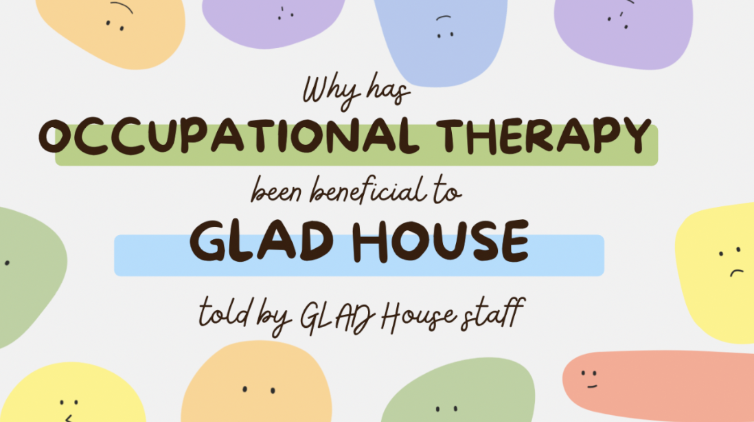

Appendix A: Literature Table

APA Reference | Research Design/  Level of Research | Participants  (who & how many) | Type of data collected | Tools/  Instruments | Results | Limitations | Comments | Theme
Fraser, K., MacKenzie, D., & Versnel, J. (2017). Complex trauma in children and youth: A scoping review of sensory-based interventions. Occupational Therapy in Mental Health, 33(3), 199-216. https://doi.org/10.1080/0164212X.2016.1265475 | Scoping Review – Level 3 Descriptive | 16 studies were included | Included both direct and indirect interventions | Included quant., qual., mixed methods, discussion, & review articles – mostly examined Ayres Sensory Integration & the Sensory Motor Arousal Regulation Treatment (SMART) | Sensory based interventions had positive outcomes for children who experienced trauma such as reduced symptoms of depression, aggression, and problematic behaviors, increase emotional awareness and self-regulation. Also selecting an environment that is calming can help with regulation and self-awareness. | Most of the studies included did not assess overall occupational performance at home, school, or community. | Specifically looks at PEO model | Sensory/mental health
Mazzeo, G. & Bendixen, R. (2023). Community-based interventions for childhood trauma: A scoping review. Occupational Therapy Journal of Research, 43(1), 14-23. https://doi.org/10.1177/15394492221091718 | Scoping Review- Level 3 Descriptive | 11 studies were included | Used the Preferred Reporting Items for Systematic Reviews (PRISMA-ScR) checklist for the scoping review. Included all different kinds of studies | Instruments included: Child Depression Inventory, Child Behavior Checklist, Strengths & Difficulties Questionnaires, UCLA PTSD-Reaction Index, Trauma Symptoms Checklist for Children, Revised Child Impact of Events Scale-13 | Decrease in PTSD symptoms, decreased depression, aggression, & social problems | Did not include articles relating to sex-trafficking & refugees, did not use a wide range of databases to search | Interventions included: CBT, TF-CBT with play and art therapy, “It’s my turn now”, Child Parent Psychotherapy, Positive Adaptations for Trauma & Healing, yoga | Mental health symptoms
Lynch, B., Brokamp, K., Scheerer, C., Bishop, M., Stauble, L., Hagedorn, B., & Endres, L. (2022). Outcomes of occupational therapy in trauma-informed care. Journal of Occupational Therapy, Schools, & Early Intervention, 15(4), 357-373. https://doi.org/10.1080/19411243.2021.2003733 | Retrospective chart review – Level 3 | 22 between ages of 0-5 years old & their caregivers | Qual data obtained from COPM (semi-structured interview) was coded & organized into subcategories, Quant data from the other instruments | COPM, Sensory Profile, Peabody Developmental Motor Scales-2 (PDMS-2), ACE Questionnaire ---- pre-post scores | Many subjects only had an initial test for each instrument, so pre-post was only used on those who had initial & final done. Only 10 subjects had final COPM, but their performance & satisfaction improved. 14 subjects were eligible & had a final sensory profile- most notable improvement being from definite dysfunction to typical performance in registration, while there was a negative change in sensory sensitivity. 9 had a final PDMS-2, grasping had a modest increase in most subjects, & visual motor showed a slight increase (average went from very poor to average) | Lots of people who only had initial tests, so impossible to complete missing data. Mamy of the caregivers could not share the whole story of each child |  | Sensory
Ballan, M., Freyer, M., & Romanelli, M. (2022). Occupational functioning among intimate partner violence survivors with disabilities: A retrospective analysis. Occupational Therapy in Healthcare, 36(4), 368-390. https://doi.org/10.1080/07380577.2021.1994684 | Retrospective, cross-sectional study – Level 3 | 205 resident records of an accessible shelter | Quantitative data from surveys/questionnaires & observations | HELPS screening tool, the other measures were developed by the study site for internal use & do not have psychometric properties, but asked about emotional & cognitive functioning, ADL execution, & participation in life rolls | Those who screened positive for a TBI reported more difficulty in participating in life roles. Residents with psychological diagnoses had higher ADL execution scores. Residents with developmental disabilities had a harder time with emotional/cognitive functioning scores. Many of the people who experienced physical abuse had a hard time with life roles only. | Limited by only using the original data found. Other than the HELPS, the measures have no psychometric validity or reliability and were not standardized. Occupational therapy students were using observation to determine functioning level. | Good explanation of intimate partner violence (IPV)
Javaherian-Dysinger, H., Krpalek, D., Huecker, E., Hewitt, L., Cabera, M., Brown, C., Francis, J., Rogers, K., & Server, S. (2015). Occupational needs and goals of survivors of domestic violence. Occupational Therapy in Healthcare, 30(2), 175-186. https://doi.org/10.3109/07380577.2015.1109741 | Retrospective design - Level 3 | 25 women living in a DV shelter | Pre- & post- OT evaluation – looked at program satisfaction & performance  Qualitative data analyzed from COPM - Quant. Data | COPM & researchers developed their own Community-based OT Evaluation | Each woman came up with their own goals (each about 5 goals)- most goals related to IADL, leisure, education, work, & social in that order  After the program – most reported significantly higher levels of performance & satisfaction with performance | Level 1 & Level 2 students were implementing groups, there was no reliability/validity of their own evaluation, limited to data due to retro. design | Groups were mandated, while individual sessions were offered | Occupational balance/deprivation
Ballan, S. & Freyer, M. (2020). Occupational deprivation among female survivors of intimate partner violence who have physical disabilities. American Journal of Occupational Therapy, 74(4). https://doi.org/10.5014/ajot.2020.038398 | Study group with less rigor - Level 3 Descriptive | 25 women with a physical disability getting help from a nonresidential DV agency | Semi-structured interviews --- Qualitative data | Qualitative data gathered from interviews | Occupational deprivation was reported to stem from educational vocational, financial, & physical barriers. Disability & IPV made it hard for subjects to gain the education needed to get a job & make money. | Study was limited by only using women with physical disabilities. Researchers worked at the site beforehand, so may have bias. | Good implications for OT & how disability can impact IPV/DV | Occupational deprivation
Fraser, K., MacKenzie, D., & Vernel, J. (2019). What is the current state of occupational therapy practice with children & adolescent with complex trauma? Occupational therapy in mental health, 35(4), 317-338. https://doi.org/10.1080/0164212X.2019.1652132 | Descriptive qualitative study – Level 3 | 9 occupational therapists | Semi-structured interviews over the phone and/or by facetime | International Classification of Functioning, Disability, & Health (ICF) framework used to identify impact of a health condition on functioning | OTs agreed that primary functional concern for children who experienced complex trauma was the inability to self-regulate age appropriately due to a lack of emotional regulation and sensory difficulties. Children often had a hard time with feeding, toileting, sleeping, maladaptive coping due to avoidant or insecure attachment styles, creating/developing relationships | Small sample size, sample size mostly consisted of U.S. & 1 U.K. member, purposive & snowball sampling used | The article goes into depth about the type of assessments & interventions used with this population | Self-regulation & sensory
Joseph, R., Casteleijn, D., Van der Linde, J., & Franzen, D. (2021). Sensory modulation dysfunction in child victims of trauma: A scoping review. Journal of Child & Adolescent Trauma, 14, 455-470. https://doi.org/10.1007/s40653-020-00333-x | Scoping Review – Level 3 Descriptive | 13 studies were included | Of the 13 articles – 9 were descriptive studies, 2 quantitative & 2 qualitative | Researchers used Arksey & O’Malley’s methodological framework for conducting scoping reviews  SMART program (Sensory Motor Arousal Regulation Tx) & ASI – STEP-SI model & other sensory modulation interventions were used | There was a positive improvement in affect, self-regulation of behavior, emotional regulation, arousal regulation, social engagement, stress reduction, & participation in ADLS with use of sensory modulation interventions mixed with ASI. | Articles did not seem to be explicit or detailed enough for full evaluation, limited evidence in the 13 articles assessed | Article is a little confusing to follow. | Sensory
Wade, T. J., Bowden, J., Sites, H. J. (2017). Child maltreatment and motor coordination deficits among preschool children. Journal of Child & Adolescent Trauma, 11, 159-162. https://doi.org/10.1007/s40653-017-0186-4 | Compared group to PDMS-2 norms – Level 3 Outcomes | 78 children between 2-5 years old referred to the Therapeutic Interagency Preschool (TIP) | Surveys & Standardized assessment (quant.) | Motor development was assessed by the PDMS-2, Maltreatment was measured by Childhood Trust Events Survey (CTES) Caregiver form adapted from the traumatic stress survey | Children showed rates of impaired motor development 5-7x higher than expected norms of the PDMS-2. Those who experienced sexual, physical, or sexual abuse experienced the highest rate. | Only looks at students already enrolled in TIP, didn’t specify if where the kids were living was impacting the scores/results | TIP is at the Cincinnati Children’s Hospital Medical Center | Motor development
Lahav, Y. (2021). Suicidality in childhood abuse survivors – the contribution of identification with the aggressor. Journal of Affective Disorders, 295, 804-810. https://doi.org/10.1016/j.jad.2021.08.138 | Cross-sectional design – level 3 | 589 adult survivors of childhood abuse | Online survey in Israeli | Childhood Trauma Questionnaire, PTSD measured with PCL-5, Identification with the Aggressor Scale, Dissociative Experiences Scale-II, Suicidal Behaviors Questionnaire-Revised (SBQ-R) | Significant associations between IWA regarding suicide ideation & behavior (SIB)- higher levels of IWA showed increase history of suicide attempts & more suicidal ideation | Relied on convenience sampling | Identification with aggressor (IWA)= pathological attachment to abuser | Mental health
Jones, M., Pierce, H., & Chapple, C. (2022). Early adverse childhood experiences and self-control development among youth in fragile families. Youth & Society 54(5), 806-832. https://doi.org/10.1177/0044118X21996378 | Longitudinal study – stratified non-random sampling | 3,444 children from the Fragile Families & Child Wellbeing Study (FFCW) | Quant data from the Self-control measure (combined questions from different scales) | 8 ACEs were evaluated with the outcome measure being self-control | (mostly looked at by age 5) As more ACEs are experienced, the less self-control an individual has & timing has an influence on self-control (older = more impact on self-control) | -2 measures of ACES not explored w/in study – did not include sexual abuse or divorce  -FFCWS did not admin. Consistent ACE inventory across time | Self-control measure came from Express Subscale of Adaptive Social Behavioral Inventory, Social Skills Rating System (SSRS), Positive Adolescent Functioning subscales, Dickham Dysfunctional Impulsivity Scale, & Achenbach Child Behavior Checklist | ACE
Shea, C., Jackson, N., & Sordille, M. (2023). Shared concepts guiding the practice of a community occupational therapy program serving youth with psychosocial challenges. The Open Journal of Occupational Therapy, 11(2), 1-17. https://doi.org/10.15453/2168-6408.1997 | Qualitative- Level 3 (Group study with less rigor) | 25 OTs who serve youth clients in community-based programs for those with psychosocial barriers | Qualitative study from interview transcripts | Semi-structured interview that consisted of 1) general work info 2) description of clients served by OT 3) specific services provided, 4) theoretical/conceptual models currently used | 4 themes – trauma lens, practicing attentive empathy, complex development mindset, & therapeutic unstructured structure | Interviews were online during COVID-19 | - Use of PEO  -more detailed description of the 4 themes w/in the article | OT perspective
Fang, X., Brown, D., Florence, C., & Mercy, J. (2012). The economic burden of child maltreatment in the United States and implication for prevention. Child Abuse & Neglect, 36, 156-165. https://doi.org/10.1016/j.chiabu.2011.10.006 | Scoping Review- Level 3 Descriptive | Child maltreatment studies & well-researched websites- depended on category | Quantitative data – all info. is secondary info. | STHC – lit review + linked surveys/Medicaid claims  LTHC – study of 3,333 women (18-64) enrolled in a large health care delivery system  PL – human capital approach  CWC – Administration for Children & Families  CJC – longitudinal study of 908 substantiated cases of CM  SPEDC – literature review | -Estimated average lifetime cost per victim of nonfatal child maltreatment = $210,012 in 2010 dollars  -all comes from healthcare costs across the lifespan, productivity losses, child welfare costs, criminal justice costs, & special education costs | -used information from CPS, which is consistently under reported cases of violence toward children  -used older research | Older information but cost of neglect or abuse | Price of ACE  CM= child maltreatment
Burke, J., Fitzhenry, M., Houghton, S., & Fortune, D. (2021). Breaking the cycle of intergenerational trauma: Evaluating the impact of parental adverse childhood experiences on parenting group outcomes using a mixed-methods approach. Children and Youth Services Review, 130. https://doi.org/10.1016/j.childyouth.2021.106223 | Mixed-methods, triangulation design with pre-post quantitative measures | 30 parents participating in the group | Qualitative- written feedback from focus group, ESQ  Quantitative- ANCOVA, sample t-tests, effect sizes | 10-week integrative parenting group – Understanding Your Child’s Behavior Programme (UYCBP)  ACEs Questionnaire, Perceived stress scale (PSS), Strengths & difficulties questionnaire (SDQ), & ‘Me as a Parent’ (MaaP) | -reduction in perceived stress  -increases in parental regulation  -included foster caregivers  - | -no control group used | Parent- child interaction, caregiver perceptions | Impact of ACEs
Center for Disease Control and Prevention. (2020, September 17). Infographic: 6 guiding principles to a trauma-informed approach. https://www.cdc.gov/orr/infographics/6_principles_trauma_info.htm |  |  |  |  | -trauma-informed care principles | Websites are inconsistent with the principles |  | TIC
Center for Disease Control and Prevention. (2023, June 29). Fast facts: Preventing adverse childhood experiences. https://www.cdc.gov/violenceprevention/aces/fastfact.html |  |  |  |  | -ACE definition  -incidence of ACEs  -consequences of ACEs  -how to prevent ACEs |  |  | ACEs
Howard, A.R.H., Lynch, A., Call, C., & Cross, D. (2020). Sensory processing in children with a history of maltreatment: An occupational therapy perspective. Vulnerable Children and Youth Studies, 15(1), 60-67. https://doi.org/10.1080/17450128.2019.1687963 | Secondary analysis of pre-test survey data – descriptive level 3 | Caregivers of 408 adopted children aged 5-12 y.o. | Collected demographic data – quantitative & the SSP – quantitative | Short sensory profile (SSP) | -children who experienced maltreatment sensory processing differences  -children who experienced neglect more likely to be under-responsive/seeking sensation & exhibited differences in auditory filtering than those who experienced abuse | -sensory processing data collected by caregiver-report  -caregivers reported type of maltreatment  -lack of knowledge of full extent of maltreatment | Overall sensory concerns for kids who experience ACEs | Sensory
Lawson, D., & Quinn, J. (2013). Complex trauma in children and adolescents: Evidence-based practice in clinical settings. Journal of Clinical Psychology, 69(5), 497-509. https://doi.org/10.1002/jclp.21990 | Scoping Review- Level 3 Descriptive | Only inclusion data was exposure to complex trauma | CPP – RCT data (quant)  ARC & ITTM only have single group, pretest/posttest design (not as much research) | Traumatic & stressful event (TSE) via psychotherapy | Early childhood (0-5)… Looks at  -Child-Parent Psychotherapy (CPP) play therapy + others  -Attachment, Self-regulation, & competency model (ARC) focuses on caregiver attachment, child’s self-regulation, child’s competency, experience integration  -Intergenerational Trauma Treatment Model (ITTM) uses CBT for parents to address the child’s trauma | Only 1 item of inclusion criteria | Also looks at model summaries for middle school & adolescents | Parent-child interaction  Interventions
Marsac, M., Kassam-Adams, N., Hildenbrand, A., Nicholls, E., Winston, F., Leff, S., & Fein, J. (2016). Implementing a trauma-informed approach in pediatric healthcare networks. JAMA Pediatrics, 170(1), 70-77. https://doi.org/10.1001/jamapediatrics.2015.2206 | Scoping Review- Level 3 Descriptive |  |  | More so, looking at previous research then discussing ways to improve on the topic | TIC minimizes potentially for medical care to become traumatic/triggering, addresses distress, provides emotional support for all family, encourages positive coping & provides anticipatory guidance to help w/ recovery | This is only an author’s manuscript, but I am confused as to how it is published? | TIC has no real guidelines- this paper provides guidelines after using factual info. | Trauma informed care (TIC)
Perez, N., Jennings, W., Baglivio, M. (2018). A path to serious, violent, chronic delinquency: The harmful aftermath of adverse childhood experiences. Crime & Delinquency, 64(1), 3-35. https://doi.org/10.1177/0011128716684806 | One group pre-post – Level 3 | 64,329 Florida Dept. Of Juvenile Justice Youth collected from 2007-2012 | Qual & quant. - Semi-structured interviews, record reviews | Positive Achievement & Change Tool (PACT) assessment -- also provides info. on ACE scores | More ACE score = more SVC & mediator variable (aggression, impulsivity, deviant peer imitation, school difficulties, substance abuse problems, & mental health problems) | Data was collected to assess tasks & needs of youth who came into contact with the juvenile justice system – not specifically for this study | SVC= serious, violent, & chronic | ACEs
Ray, D., Burgin, E., Gutierrez, D., Ceballos, P., Lindo, N. (2021). Child-centered play therapy and adverse childhood experiences: A randomized controlled trial. Journal of Counselling & Development, 100(2), 134-145. https://doi.org/10.1002/jcad.12412 | RCT – Level 2 | 120 elementary school students at Title 1 schools | Linear mixed methods – quantitative & qualitative | ACE Questionnaire – expanded, social emotional & resilience scales- parent (SEARS-P), & direct observation form (DOF) | Increase in social-emotional competencies (empathy, social competence, & self-regulation/responsibility) & decrease in total behavior problems in kids who participated in CCPT (child-centered play therapy) | Over-representation of boys comprising the sample (76%), ACEs often underreported | CCPT = developmentally responsive, play0based mental health intervention for kids 3-10 y.o. – utilizes play, natural language of children, & therapeutic relationship to provide a safe, consistent env. | Intervention for ACEs
Thurston, H., Bell, J., Induni, M. (2018). Community-level adverse experiences and emotional regulation in children & adolescents. Journal of Pediatric Nursing, 42, 25-33. https://doi.org/10.1016/j.pedn.2018.06.008 | Cross-sectional study - level 2 | 65,680 children aged 6-17 y.o. | Quantitative & qualitative – telephone survey from caregiver | Child & adolescent health measurement initiative/data resource center (CAHMI/DRC)community levels were measured by statements | -males experienced more ACEs than females & most were over 9 y.o.  -ACEs significantly & inversely related to emotional regulation | Cross-sectional design designates associations, not causality, ACEs underreported b/c completed by caregiver | Demographics of ACEs | ACE

Appendix B: Needs Assessment
Purpose
This Doctoral Capstone aims to enhance self-regulation and life skills in children affected by adverse childhood experiences (ACEs), particularly those related to caregiver substance use disorders or addiction. Substance abuse often results in multiple ACEs, increasing a child’s risk for behavioral, mental, and physical issues. Children at GLAD House, an after-school program designed to reduce and delay the impacts of substance abuse for children, average four ACEs (M. Cox, personal communication, April 4, 2024). After interviewing Michelle Cox and Ashley Tomlinson, this Doctoral Capstone includes four projects: updating the sensory areas at GLAD House, building carryover skills, revising the life skills curriculum, and providing continuing education units (CEUs) for staff. Improving self-regulation and life skills can delay first use of substances and reduce health risks (Centers for Disease Control and Prevention [CDC], 2023). Within this paper, the current literature will be reviewed, as well as the targeted population to gain a deeper understanding of the need for this Doctoral Capstone.
Literature Review
The three categories of ACEs are abuse, neglect, and household dysfunction. Abuse includes physical, emotional, and sexual forms, while neglect encompasses both physical and emotional forms. Household dysfunction includes mental illness, incarcerated household members, substance abuse, divorce or parental separation, and intimate partner violence (Felitti et al., 1998). As the number of ACEs increases, so does the risk of negative life outcomes associated with them, such as poor health and diminished well-being across the lifespan (CDC, 2023). ACEs activate a child’s sympathetic nervous system, prioritizing survival and impairing self-regulation and healthy decision-making.
Research shows that ACEs can lead to delayed development, impaired physiological function, and difficulties in social relationships due to a lack of trust (CDC, 2023; Felitti et al., 1998; Fraser et al., 2017; Fraser et al., 2019; Jones et al., 2022; Howard et al., 2020; Perez et al., 2018). Children who experienced ACEs are also more likely to experience mental health issues like depression and anxiety, as well as physical conditions like obesity, cancer, and diabetes (CDC, 2023; Cleveland Clinic, 2023; Felitti et al., 1998; Kerker et al., 2015). The impact of ACEs on children’s development and overall health highlights the critical need for intervention.
To reduce the common impacts of experiencing ACEs, building self-regulation strategies is a widely used intervention that engages the parasympathetic nervous system, which allows the child to relax and digest. Incorporating sensory integration can enhance emotional regulation, reduce stress, increase play, and improve social relationships (Fraser et al., 2017; Joseph et al., 2021; Sanders et al., 2016; Warner et al., 2013). Updating the sensory areas can help the child self-regulate and have a feeling of security and relaxation, thus improving self-regulation. Additionally, consistency across home, school, and community is essential for effective change. Educating caregivers and those involved in a child’s life on regulation strategies is crucial for promoting an understanding and allows the adult to adjust their expectations and attitudes toward the children and themselves (Porter et al., 2023). Children who can apply self-regulation skills across environments are more likely to be successful in making healthy life decisions and reducing the impact of ACEs.
Education is another vital intervention for addressing the impacts of ACEs. GLAD House currently has a life skills curriculum due to activities of daily living (ADLs) being negatively impacted by complex trauma, like having household dysfunction in the form of substance abuse (Walsh-Garcia et al., 2023). Regular updates to this curriculum ensure children learn relevant, evidence-based daily living skills without repeating information. Additionally, providing staff at GLAD House with CEUs during their professional development trainings ensures they receive current and applicable information to their job at the organization (Archer et al., 2020). GLAD House currently has professional development trainings, but the staff are not receiving CEUs for the courses. Therefore, providing CEUs for trainings they complete can increase the usability of the information since it directly applies to GLAD House and reduce the time spent outside of the organization.
Population Analysis
Within this Doctoral Capstone, different populations are being served. First and foremost are the children, aged 5-12 years old, who have substance abuse within their homes and attend GLAD House. Children who have substance abuse within their homes are at a higher risk for developing mental illness, substance abuse disorders, and other developmental delays due to the instability at home and genetic predisposition. As of 2022, the average age of first use of alcohol or other drugs is 12.8 years of age within the Cincinnati area (Sawmiller, 2022). Additionally, 70% of children who try an illegal drug before the age of 13 are likely to develop a substance abuse disorder (National Center for Drug Abuse Statistics, 2023). GLAD House targets children before they reach that age to help delay the age of first use. Most of the children are referred to GLAD House through foster parents or Cincinnati Public Schools (M. Cox, personal communication, April 4, 2024). To be eligible for GLAD House the child must be within the restricted age range, be Ohio Medicaid eligible, live within Hamilton County, and have a caregiver who has or currently struggles with addiction (GLAD House, 2024).
Additionally, employees at GLAD House and those who work closely with the children will also be part of the served population. They will benefit from the various projects, which aim to enhance communication and update the organization. Other professionals including teachers, guardian ad litems, social workers, case managers, and others will benefit from the development of carryover skills and furthering continuity of care between GLAD House, schools, homes, and the community.
Justification
This Doctoral Capstone is essential due to the high-risk children at GLAD House face from their exposure to multiple ACEs. Experiences such as caregiver substance abuse can lead to lifelong physical, emotional, and mental health issues that are often preventable. While GLAD House is committed to prevention, the organization lacks the time and resources to stay current with effective interventions. Therefore, updating the sensory areas and life skills curriculum is vital for the organization’s effectiveness. Providing staff with CEUs enables them to apply relevant and current knowledge more effectively. Additionally, this Doctoral Capstone can help GLAD House achieve its goal of pushing back the age of first use, thus reducing the cycle of addiction between caregiver and child. This can occur through increasing carryover skills related to self-regulation. Collaborating with all individuals involved in the children’s lives will improve the effectiveness of self-regulation strategies and ensure consistency. The children attending GLAD House are frequently forced to change their environment and are constantly interacting with new adults, so creating a universal educational experience for caregivers is essential for effective follow-through. Ultimately, the Doctoral Capstone aims to empower GLAD House to implement current evidence-based strategies that improve self-regulation and foster a supportive environment for children to break the cycle of addiction and promote healthier futures for the children attending.

Appendix B: Literature Review
Problem Statement
Adverse childhood experiences (ACEs) are any traumatic event that occurs before a child turns 18 years old, including abuse, neglect, and household dysfunction. According to the Centers for Disease Control and Prevention (CDC) (2023), roughly 64% of American adults reported experiencing at least one ACE before the age of 18, while 1 in 6 reported 4 or more ACEs. Experiencing an ACE or trauma of any kind puts people more at risk for developing physical and mental health conditions, engaging in risky behaviors, developing unhealthy relationships, instability in work, education, and within the household, and poor self-regulation (CDC, 2023; Thurston et al., 2018). Not only do ACEs cause negative consequences, but are also costly due to additional healthcare, special education, and criminal justice costs stemming from children struggling to self-regulate and establish and develop healthy relationships (Fang et al., 2012). With a trauma informed care (TIC) approach, occupational therapy (OT) can help reduce the possible risk outcomes and improve overall quality of life.
Review of the Literature
ACEs commonly lead to negative life outcomes due to the increased risks associated with the experience. The outcomes are due to sensory, regulation, and attachment problems with issues associated with feeling unsafe and stressed. People who experience trauma are more likely to live in a flight or fight response causing dysregulation. The dysregulation often occurs due to lack of emotional regulation, sensory stimulation being imbalanced, or a lack of social interactions. An occupational therapy practitioner (OTP) can help work through these problems that stem from ACEs and help with the dysregulation that children often face. Specifically, OTPs work on sensory processing and integration, as well as emotional and social awareness and regulation. The possible risk outcomes of experiencing ACEs can be prevented and improved with OT services.
Result of experiencing ACEs
Along with the mental health aspect of trauma, there are also issues with sensory stimulation, self-regulation, and relationships that can last a lifetime if not addressed. ACEs impact a child’s ability to process sensory information due to the trauma impacting brain development (Fraser et al., 2017; Fraser et al., 2019; Joseph et al., 2021). Before completing more advanced tasks, the brain needs to be able to process and integrate sensory information. Children who were abused tend to be over-responsive to touch, smell, and taste, while those who were neglected tend to be more sensory seeking (Howard et al., 2020; Lynch et al., 2021). Self-regulation can also be related to sensory processing problems, as children who have experienced ACEs are often unable to regulate when stimulated by certain senses. More frequent ACEs negatively impact self-regulation, which results in increased impulsivity (Jones et al., 2022; Perez et al., 2018). Additionally, experiencing ACEs commonly causes relationship issues often having to do with insecure attachment due to feeling unsafe, low self-esteem, and lack of trust (Shea et al., 2023; Lawson & Quinn, 2013). Therefore, children who experiences ACEs typically develop unhealthy relationships or they do not develop any deep, long-lasting relationships. Mental health conditions that are regularly associated with trauma (anxiety, depression, PTSD) tend to intensify the sensory, regulation, and relationship problems that children who experienced trauma often face.
Interventions and Outcomes
OTPs have a variety of interventions to improve performance and participation for a child who has experienced trauma. One commonly used intervention is Ayres Sensory Integration (ASI) or other sensory interventions. Research indicates sensory based interventions can cause a decrease in stress, symptoms of depression, aggression, and behavioral outbursts, while causing an increase in emotional awareness and overall self-regulation (Fraser et al., 2017; Joseph et al., 2021; Lynch et al., 2022). By addressing sensory processing or integration a child’s social interactions and play skills, and education related activities would be more successful. Additionally, OTPs can take a TIC approach, which includes using treatment sessions where they work with the caregiver and child simultaneously, so they build a safe, healthy, and trusting relationship. In doing so, research showed a reduction in PTSD symptoms, aggressive behaviors, and social problems (Burke et al., 2021; Fraser et al., 2017; Mazzeo & Bendixen, 2023). Lastly, play therapy can be used to teach social skills and reduce disruptive behaviors (Mazzeo & Bendixen, 2023; Ray et al., 2021). Using a combination of these OT interventions can help a child feel more regulated, safe, and improve their overall wellbeing.
Outcome measures
Measuring the outcomes related to self-regulation, amount and type of ACEs, mental health status, and relationship stability requires many different types of assessments and tests to be used. Much of the research indicates interviews with both the child and the caregiver and surveys specific to a study are used commonly to measure ACEs in children and effectiveness of interventions (Fraser et al., 2019; Perez et al., 2018; Shea et al., 2023). Nevertheless, the most utilized assessments were the Canadian Occupational Profile Measure (COPM), Sensory Profile, and ACE Questionnaire (Burke et al., 2021; Javaherian et al., 2015; Jones et al., 2022; Howard et al., 2020; Lynch et al., 2022). The COPM correlates to both self-regulation and client satisfaction with their occupational performance, while the sensory profile provides information regarding self-regulation regarding sensory issues. The ACE questionnaire identifies trauma experienced through ACEs providing insight into occupational performance issues found within the COPM. The provided assessments were the most common within the literature and provided insight into what interventions the OTPs needed to complete to enhance or create certain skills that will reduce the effects of the ACEs.
Conclusion
ACEs have negative impacts on children that can last a lifetime. OTPs can help reduce the likelihood of the risk outcomes that are commonly associated with ACEs such as behavioral risks like smoking and missing work and/or physical and mental health related like having a stroke, STDs, or depression. In doing so, OTPs are helping the high percentage of the population that experience ACEs live longer lives, while promoting participation and optimal performance. The OTPs can help with sensory, self-regulation, and relationship problems among other aspects, therefore, improving overall quality of life and well-being. While ACEs can be detrimental to a child’s life, OTPs can help them gain their confidence and feel safe and satisfied with their life.

Appendix C: Capstone Goals and Objectives for a Capstone Project Table and a Capstone Experience Table
Project Objectives
Goal# | Project Goal | Activities | Proposed Timeline for Meeting Goal | Proposed Evidence of Achievement
1 | Student will provide at least 3 updates to the sensory room and gross motor bin. | - Research on the least breakable, most reliable sensory equipment  - Obtain a grant to pay for sensory equipment | - 9/26/25  - Grant written by 8/18 | - At least 2 EBP articles supporting the use of recommended equipment  - At least 3 pieces of equipment are ordered
2 | Student will have at least 10 people participate in her study (focus group, educational module, & follow-up survey). | - Student will submit for IRB approval including questions asked within the focus group  - Use open coding for the focus groups to find themes to be discussed within the educational module | - 12/23/24  - 10/3/25 | - IRB approval  - At least 3 themes are found & addressed in the educational module based on the focus groups
3 | Student will create an educational module to create consistent language and strategies used within different professions. | - Create semi-structured interview guide for the focus groups  - A slides deck will be created with recordings will be sent to at least 15 professionals who work with the GLAD House population. | - 11/18/24  - 10/17/25 | - At least 10 open-ended questions regarding GLAD House, social-emotional regulation, and role of their profession  - Educational module is completed and kept under 60 minutes in length to complete.
4 | Student will create at least instructional handouts on how to obtain CEUs for at least 2 different professions. | - Research how to obtain CEUs for each profession  - Contact the boards for social work, education, and psychology of Ohio  - Apply for CEU credits for two different professional developments  - Create instructional handouts | 1&2. 10/20/25  - 11/7/25  - 11/7/25 | 1&2. Emails sent to at least 3 different boards to obtain CEU approval  - Completed CEU application  - Instructional handouts are generated for at least 2 different professions

Learning Objectives
Goal# | Learning Goal | Activities to Achieve Goal | Proposed Timeline for Meeting Goal | Proposed Evidence of achieving Learning Goal
1 | Practice: Demonstrate effective communication skills and work interprofessionally with those who receive and provide care/services. | - Lead an interprofessional focus group to help determine ideas for building continuity of care  - Be able to identify sensory needs of children when utilizing sensory room/gross motor bin | - 9/26/25  - 9/26/25 | - Have at least 10 people participate in the focus groups/interviews evidenced by master list  - At least 3 sensory room needs are documented
2 | Ethics: Display positive interpersonal skills and insight into one’s professional behaviors to accurately appraise one’s professional disposition strengths and areas for improvement. | - Create at least 3 recommendations based on research for the sensory room and gross motor bin  - Adhere to autonomy of the focus group | - 9/26/25  - 9/19/25 | - Identify at least 3 pieces of sensory equipment that is backed by research  - Informed consents were signed by those willing to participate in the focus groups/ interviews
3 | Advocacy: Exhibit the ability to practice educative roles for consumers, peers, students, interprofessionals and others. | - Create an online training module for professionals working with the children  - Create/gather list of interprofessional team members that work with the children to start the continuity of care focus groups | - 10/17/25  - 8/27/25 | - Records that at least 10 professionals completed the online training module  - Initial email sent to at least 20 people of differing professions
4 | Leadership: Develop essential knowledge and skills to contribute to the advancement of occupational therapy through scholarly activities. | - Create educational materials focused on holistic and continuous care between interprofessional teams  - Create handouts on how to apply for CEUs, so they can continue to receive credit | - 10/17/25  - 11/7/25 | - At least 10 follow-up surveys are completed  - One handout is created for applying for CEUs
5 | Scholarship: Apply a critical foundation of evidence based professional knowledge, skills, and attitudes. | - Research sensory equipment that is sturdy, reliable, and beneficial for this population  - Research best types of social-emotional regulation strategies to create the educational materials to show it is backed by evidence | - 9/19/25  - 9/26/25 | - Present 3 recommended items backed by evidence (reference list) to GLAD House staff  - Educational module contains a reference list to show it is evidence-based

Individual Student Goals
1 | By the end of my time at GLAD House, I will feel more confident about working as part of an interprofessional team based on a Likert scale assessment. | - Lead a focus group with different professionals.  - Increase my understanding of each profession’s role within the children’s lives to know how OT can be a part of the team. | - 9/26/25  - 11/15/25 | - At least 3 themes found from the focus group to be addressed in educational material  - Be able to identify at least 2 ways OT can work as part of the interprofessional team written in capstone journal or within educational module
2 | By the end of my time at GLAD House, I will be able to recommend at least 3 beneficial items to be added to sensory rooms that are not breakable and do not require training of staff. | - Research reliable, unbreakable sensory equipment  - Provide at least 3 recommendations of sensory equipment to the team at GLAD House for financial approval | - 9/19/25  - 9/26/25 | - Sensory equipment is backed by research as per reference list in presentation to GLAD House staff  - 3 sensory- equipment recommendations presented to GLAD House staff are bought using grant money attained by student

Appendix D: Signed Memorandum of Understanding
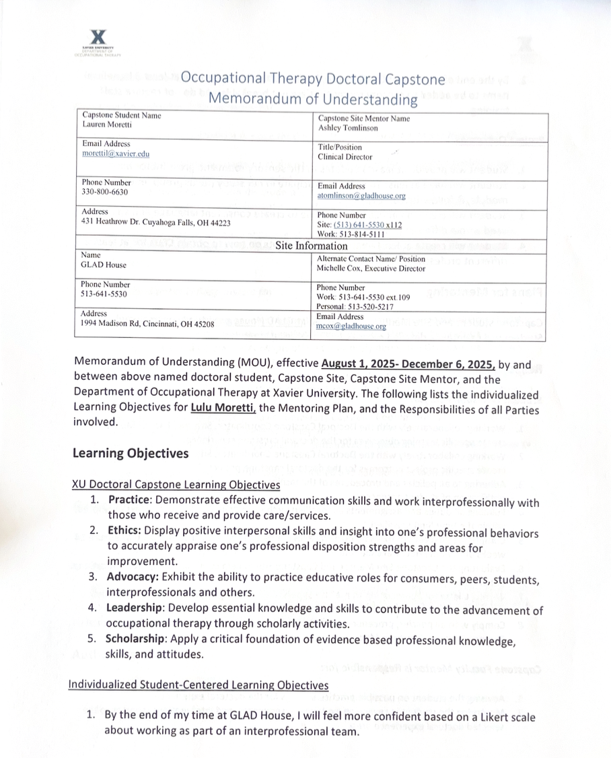

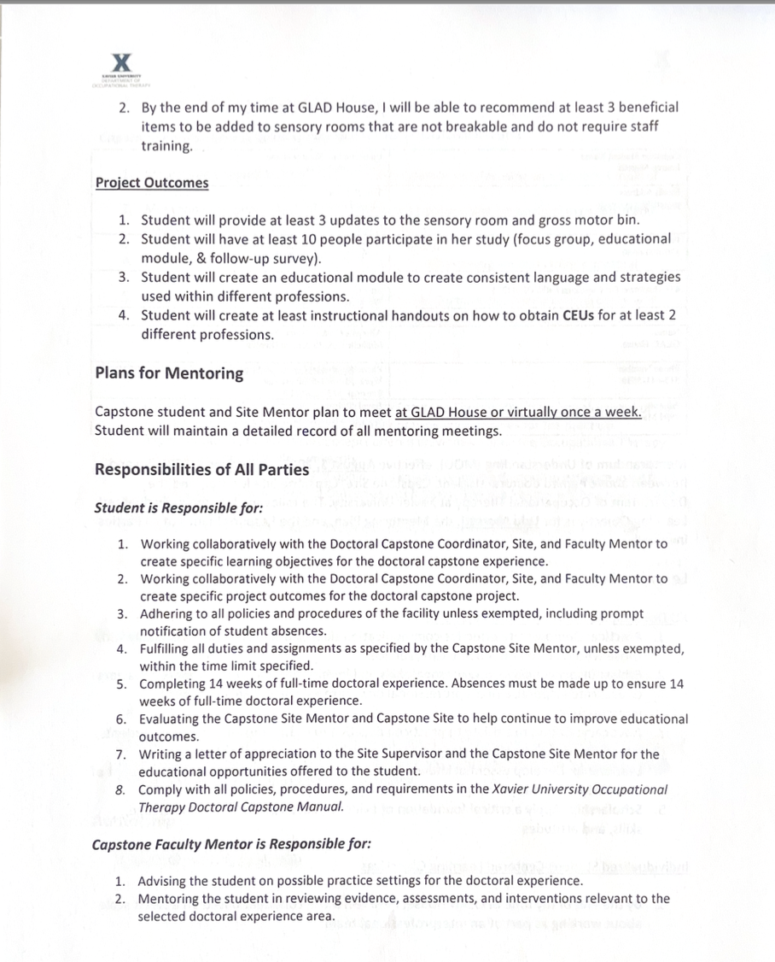

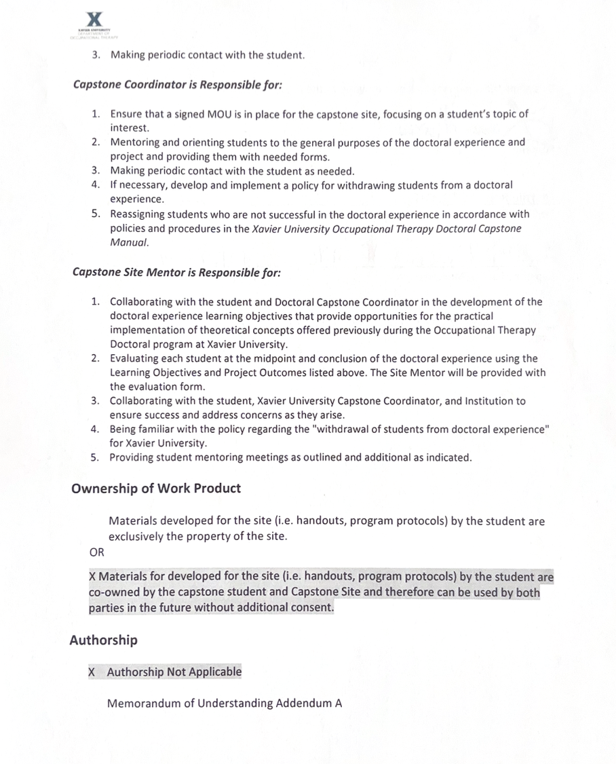
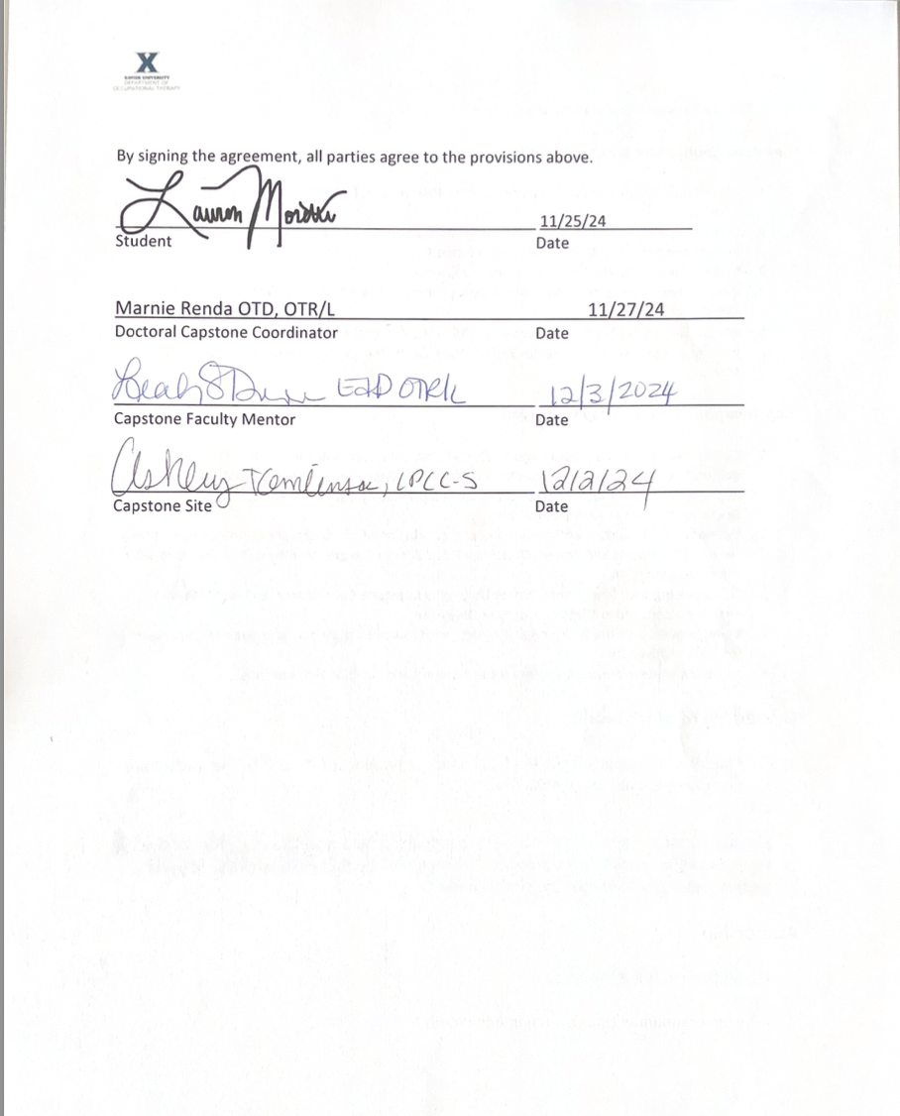

Appendix E: IRB Letter of Response

Appendix F: Educational Module
Attached below is the link to the educational module created after all interviews were completed. The educational module was shared with those who participated in an interview, and participants were asked to share the module with others as they see fit. An adapted version of this presentation was utilized by OT student to educate staff on the different self-regulation strategies, resources, and to bring awareness toward ACEs.

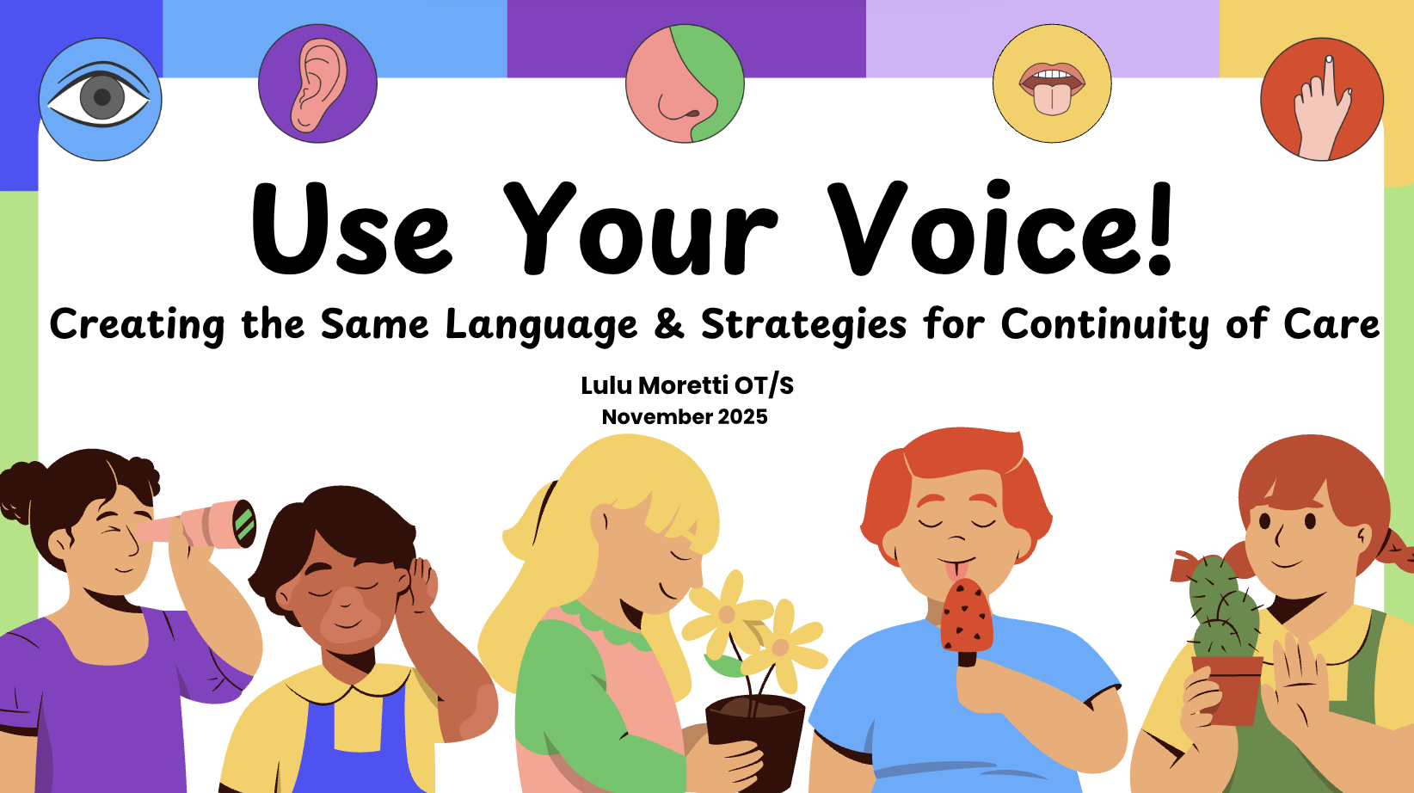

Appendix G: Sensory Support Recommendations
Attached below are the links and screenshots to the sensory supply recommendations. The first link is the slideshow of the sensory equipment with images, prices, and prioritization. The second link provides an Excel sheet with the name of the equipment, price, location of where the item would be located in GLAD House, rationale for the item, and the link to the item. The items in green have been purchased or donated prior to the end of capstone. The items highlighted in orange are options of items that provide the same input, while the pink is the most highly recommended of the options.

Link for Sensory Slideshow:
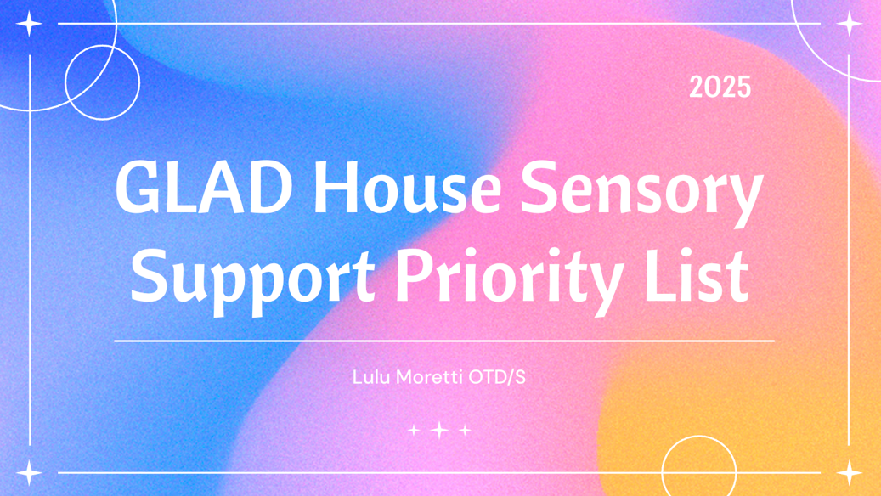

Link for Excel Sheet with rationale:
https://docs.google.com/spreadsheets/d/1rHQODb8OnoVJTlX8HtAnww7tbMVtzzaBAA4OgYQcCtM/edit?usp=sharing

Appendix H: Week-by-Week Project Plan
Week | Activities | Related Goal
1  8/18 | Orientation/Observation  - Work on training for GLAD House  - Observe schedule, children, different classes  - Create/gather list of interprofessionals involved in the children’s lives to start emailing for continuity of care materials
2  8/25 | Orientation/Observation  - Finish training for GLAD House  - Observe schedule, children, different classes  - Begin researching CEU’s application process  - Observe + conversations with children & staff about sensory room + gross motor bin  - Continue to create/gather list of interprofessionals involved in the children’s lives to start emailing for continuity of care materials – Send initial email | L – 1.2  L – 3.2
3  9/1 | Gather information  - Observe + conversations with children & staff about sensory room + gross motor bin  - Begin research on sensory equipment  - Respond about individual interviews  - Send initial email again in case of spam  - Send meeting reminder email | P - 1.1  L – 1.2  L – 5.1  S – 2.1
4  9/8 | Start focus Groups + Research  - Have timeslots for focus groups & individual interviews  - Send meeting reminder emails  - Research social-emotional strategies & roles of the different professionals attending the interviews/focus groups  - Research sensory equipment | P – 1.1  L – 1.1  L – 2.2  L – 5.1  L – 5.2  S – 1.1  S – 1.2  S – 2.1
5  9/15 | Focus groups  - Have timeslots for focus groups & individual interviews  - Send meeting reminder email  - Continue researching sensory equipment  - Begin researching social-emotional strategies + common language | P – 1.1  L – 2.2  L – 5.1  L – 5.2  S – 1.1  S – 1.2  S – 2.1
6  9/22 | Sensory Equipment Recommendations + Coding  - Any make-up focus groups or individual interviews  - Present sensory equipment recommendations to staff  - Complete open-coding on transcriptions of focus groups/individual interviews | P – 1.1.  P – 1.2  P – 2.2  L – 2.1  L – 2.2  S – 1.1  S – 1.2  S – 2.2
7  9/29 | Themes + Educational Module  - Begin to find themes from coding transcriptions  - Begin creating educational module  - Continue researching roles of professionals & social-emotional learning & strategies | P – 2.2  P – 3.2  L – 3.1  L – 4.1
8  10/6 | Project Implementation – Educational Module + Buy Sensory Equipment  - Work on creating educational module that is evidence-based  - Adjust sensory equipment based on feedback from staff  - Order equipment | P – 3.2  L – 3.1  L – 4.1
9  10/13 | Project Implementation - Educational Module  - Add auditory recordings to educational module  - Send educational module by end of week | P - 3.2  L – 3.1  L – 4.1
10  10/20 | Project Implementation - CEU  - Professionals working on educational module/follow-up survey  - Begin applying to boards for a CEU occurring in December | P – 4.1  P – 4.2  P – 4.3
11  10/27 | Project Implementation - CEU  - Professionals working on educational module/follow-up survey  - Continue working on applying for CEUs | P – 4.1  P – 4.2  P – 4.3
12  11/3 | Project Implementation – CEU + Implement Sensory Equipment  - Professionals working on educational module/follow-up survey  - Continue working on CEUs  - Create handouts with instructions on how to obtain CEUs for each professional board  - Implement sensory equipment & instruct staff how to use it | P – 4.3  P – 4.4  L – 4.2
13  11/10 | Data Analysis/ Results  - All follow-up surveys are due  - Analyze data from follow-up survey
14  11/17 | Data Analysis/ Results /Discussion  - Analyze the data  - Create poster for repository  - Create presentation for symposium
15  11/24 | Dissemination  - 3 min. video  - Create poster for repository  - Continue working on presentation for symposium
16  12/1 | Dissemination  - Final edits to presentation  Capstone Symposium  - Present

References
Archer, A., Berry, I., Bajawa, U., Kalda, R., & Di Ruggiero, E. (2020). Preferred modalities for delivering continuing education to the public health workforce: A scoping review. Health Promotion and Chronic Disease Prevention in Canada, 40(4). https://doi.org/10.24095/hpcdp.40.4.03
Burke, J., Fitzhenry, M., Houghton, S., & Fortune, D. (2021). Breaking the cycle of intergenerational trauma: Evaluating the impact of parental adverse childhood experiences on parenting group outcomes using a mixed-methods approach. Children and Youth Services Review, 130. https://doi.org/10.1016/j.childyouth.2021.106223
Center for Disease Control and Prevention. (2020, September 17). Infographic: 6 guiding principles to a trauma-informed approach.
Centers for Disease Control and Prevention. (2023, June 29). Adverse childhood experiences (ACEs). https://www.cdc.gov/violenceprevention/aces/fastfact.html
Cleveland Clinic. (2022, March 18). What is sensory play? The benefits for your child and sensory play ideas. https://health.clevelandclinic.org/benefits-of-sensory-play-ideas
Cleveland Clinic. (2023, April 4). Adverse childhood experiences (ACEs). https://my.clevelandclinic.org/health/symptoms/24875-adverse-childhood-experiences-ace

Fang, X., Brown, D., Florence, C., & Mercy, J. (2012). The economic burden of child maltreatment in the United States and implication for prevention. Child Abuse & Neglect, 36, 156-165. https://doi.org/10.1016/j.chiabu.2011.10.006

Felitti, V., Anda, R., Nordenberg, D., Williamson, D., Spitz, A., Edwards, V., Koss, M., & Marks, J. (1998). Relationship of childhood abuse and household dysfunction to many leading causes of death in adults: The adverse childhood experiences study. American Journal of Preventative Medicine 14(4), 245-258.
Fraser, K., MacKenzie, D., & Versnel, J. (2017). Complex trauma in children and youth: A scoping review of sensory-based interventions. Occupational Therapy in Mental Health, 33(3), 199-216. https://doi.org/10.1080/0164212X.2016.1265475
Fraser, K., MacKenzie, D., & Vernel, J. (2019). What is the current state of z practice with children & adolescent with complex trauma? Occupational therapy in mental health, 35(4), 317-338. https://doi.org/10.1080/0164212X.2019.1652132
GLAD House. (2024). Champs program. https://www.gladhouse.org/champs-1
Howard, A.R.H., Lynch, A., Call, C., & Cross, D. (2020). Sensory processing in children with a history of maltreatment: An occupational therapy perspective. Vulnerable Children and Youth Studies, 15(1), 60-67. https://doi.org/10.1080/17450128.2019.1687963
Irvine-Brown, L.,Ware, V.A., Malfitano, A., & Di Tommaso, A. (Aug. 2021). Re-engaging in our role with communities: The coupling of occupational therapy and community development. Australian Occupational Therapy Journal, 68(4), 308-316. https://doi.org/10.1111/1440-1630.12728
Javaherian-Dysinger, H., Krpalek, D., Huecker, E., Hewitt, L., Cabera, M., Brown, C., Francis, J., Rogers, K., & Server, S. (2015). Occupational needs and goals of survivors of domestic violence. Occupational Therapy in Healthcare, 30(2), 175-186. https://doi.org/10.3109/07380577.2015.1109741
Joesph, R., Casteleijn, D., van der Linde, J., & Franzen, D. (2021). Sensory modulation dysfunction in child victims of trauma: A scoping review. Journal of Child & Adolescent Trauma, 14, 455-470. https://doi.org/10.1007/s40653-020-00333-x
Jones, M., Pierce, H., & Chapple, C. (2022). Early adverse childhood experiences and self-control development among youth in fragile families. Youth & Society 54(5), 806-832. https://doi.org/10.1177/0044118X21996378
Kerker, B., Zhang, J., Nadeem, E., Stein, R., Hurlburt, M., Heneghan, A., Landsverk, J., & Horwtiz, S. (2015). Adverse childhood experiences and mental health, chronic medical conditions, and development in young children. Academic Pediatric Association, 15(5), 510-517.
Kuypers, L. (2011). The zones of regulation: A curriculum designed to foster self-regulation and emotional control. Think Social Publishing.
Lawson, D., & Quinn, J. (2013). Complex trauma in children and adolescents: Evidence-based practice in clinical settings. Journal of Clinical Psychology, 69(5), 497-509. https://doi.org/10.1002/jclp.21990

Lynch, B., Brokamp, K., Scheerer, C., Bishop, M., Stauble, L., Hagedorn, B., & Endres, L. (2022). Outcomes of occupational therapy in trauma-informed care. Journal of Occuaptional Therapy, Schools, & Early Intervention, 15(4), 357-373. https://doi.org/10.1080/19411243.2021.2003733

Mahler, K. (2017). The interoception curriculum: A step-by-step framework for developing mindful self-regulation. APPC Publishing.

Matson, R., Barnes-Brown, V., & Stonall, R. (2023). The impact of childhood trauma on sensor processing and connected motor planning and skills: A scoping review. National Library of Medicine, 17(2),447-456. https://doi.org/10.1007/s40653-023-00598

Marsac, M., Kassam-Adams, N., Hildenbrand, A., Nicholls, E., Winston, F., Leff, S., & Fein, J. (2016). Implementing a trauma-informed approach in pediatric healthcare networks. JAMA Pediatrics, 170(1), 70-77. https://doi.org/10.1001/jamapediatrics.2015.2206

Mazzeo, G. & Bendixen, R. (2023). Community-based interventions for childhood trauma: A scoping review. Occupational Therapy Journal of Research, 43(1), 14-23. https://doi.org/10.1177/15394492221091718
National Center for Drug Abuse Statistics. (2023). Drug abuse statistics. https://drugabusestatistics.org/
Perez, N., Jennings, W., Baglivio, M. (2018). A path to serious, violent, chronic delinquency: The harmful aftermath of adverse childhood experiences. Crime & Delinquency, 64(1), 3-35. https://doi.org/10.1177/0011128716684806
Porter, L., Lane, S., Demchick, B., Sweeney, J., Mullens, P., & Kearney, B. (2023). Parents as adult learners in occupational therapy for children with sensory challenges: A scoping review. American Journal of Occupational Therapy, 77(1). https://doi.org/10.5014/ajot.2023.050078
Ray, D., Burgin, E., Gutierrez, D., Ceballos, P., Lindo, N. (2021). Child-centered play therapy and adverse childhood experiences: A randomized controlled trial. Journal of Counselling & Development, 100(2), 134-145. https://doi.org/10.1002/jcad.12412
Sanders, H., Sears, A., & Apodaca, J. (2016). Sensory-focused play & attachment: Interdisciplinary collaboration in treatment foster care. SIS Quarterly Practice Connections 1(1), 2-4.
Sawmiller, S. (2022). Student survey: 2022 national findings. [PowerPoint Slides]. PreventionFirst!. https://www.prevention-first.org/media/centers/CPS/2022%20Regional%20Results%20Presentation.pdf
Shea, C., Jackson, N., & Sordille, M. (2023). Shared concepts guiding the practice of a community occupational therapy program serving youth with psychosocial challenges. The Open Journal of Occupational Therapy, 11(2), 1-17. https://doi.org/10.15453/2168-6408.1997
Thurston, H., Bell, J., Induni, M. (2018). Community-level adverse experiences and emotional regulation in children & adolescents. Journal of Pediatric Nursing, 42, 25-33. https://doi.org/10.1016/j.pedn.2018.06.008
Walsh-Garcia, S., Cremin, K., & Spirtos, M. (2023). An exploration of occupational therapy practices with children and adolescents experiencing complex trauma: An irish perspective. Occupational Therapy in Mental Health. https://doi.org/10.1080/0164212X.2023.2283500
Warner, E., Koomar, J., & Lary, B. (2013). Can the body change the score? Application of sensory modulation principles in the treatment of traumatized adolescents in residental settings. Journal of Family Violence, 28, 729-738. https://doi.org/10.1007/s10896-013-9535-8
Williams, M.S., & Shellenberger, S. (1996). How does your engine run? A leader’s guide to the alert program for self-regulation. TherapyWorks, Inc.

